# Team Valiant

Website:

GitHub Repository: <https://github.com/Mitchell-38/TeamValiant>

## Personal Information

**Mitchell Broadbent** (s3858182)

Mitchell’s interest in IT was not established by an event or person; rather it was formed by a conglomeration of known figures and works both fictional and existent. Mitchell is a natural born Australian. He is interested in the problem solving and diagnostic aspects of programming, and potentially systems administration. In his spare time, Mitchell likes to read and look after his two pet rats.

**Tim Osborne** (s3860099)

Tim’s interest in IT started from a young age; watching his family start using computers and playing interactive games where he could colour, draw, point and click. He continued to explore this interest by taking IT classes in high school and would like to learn more about software. Tim is a second-generation Australian, knows a little German from his grandmother, and in his spare time, likes to read high fantasy and alternate history fiction. He has also recently taken to cooking.

**Eenu Monga** (s3858815)

Eenu’s interest in IT started with the data science boom and continued growing after seeing firsthand how IT could be used in the workplace to provide solutions and efficiencies. She is interested in programming, development, and testing. Eenu is a first generation Australian, born to Indian parents, knows some Hindi and Punjabi. In her spare time, she likes to read, watch episodes of Air Crash Investigation, and think about a making a wall-sized aquarium.

**Tyson Carroll** (s3660241)

Tyson’s interest in IT started when he got his first computer at the age of ten and started playing games and was re-ignited after he started building computers for some of his friends. He is currently interested in cyber security and game development. Tyson is Australian born, and his father’s side of the family is from Turkey. His interests include basketball, video editing, gaming, and of course, computers.

**Wenjun Bi** (s3858029)

Wenjun’s interest in IT started after he saw SQL data presented visually in a creative and intriguing manner, and he hopes to be able to analyse data and present it in the same way to others. Wenjun is of Chinese background, and can speak English, Cantonese, and Intermediate Mandarin. In his spare time, he likes to play basketball, video games and surf the web.

## Team Profile

For our previous individual assignments, each team member had to complete three online personality tests:

1. Myers-Briggs Type Indicator (MBTI) test
2. Learning style test
3. A test of their own choosing  
     
   Each team member used the MBTI test provided by the website 16Personalities and different providers for the Learning style tests.

|  |  |  |  |
| --- | --- | --- | --- |
| **Team Member** | **MBTI Result** | **Learning Style result** | **Miscellaneous Test & Result** |
| Mitchell | INTP-A Logician | 1. 50% visual 2. 30% auditory 3. 20% kinaesthetic | **Enneagram test**  Result: Type 3 – Performer. |
| Tim | INFP-T Mediator | Visual | **Emotional intelligence test**  Result: 14/20 |
| Eenu | ISFP-T  Adventurer | Multimodal learner:   1. Visual 2. Aural 3. Read/write 4. Kinesthetic | **Big Five Personality Test** Result:   1. 69% openness 2. 58%   conscientiousness 3. 35% extroversion 4. 67% agreeableness 5. 60% neuroticism. |
| Tyson | ISFJ-T Defender | 1. 40% visual 2. 30% auditory 3. 30% tactile | **Big Five Personality Test** Snapshot report result: Extroversion 58%; “fall[s] into the middle of the introversion and extroversion continuum…” |
| Wenjun | INFP-A /  INFP-T  Mediator | Visual | **What hobby should I have test?**  Result: photography. |

*Table 1. Personality test results for each team member*

The 16Personalities’ MBTI test determines personality types by measuring five different personality aspects. These aspects are:

1. The mind aspect (**I or E**) measures if someone is more introverted or extroverted.
2. The energy aspect (**S or N**) measures if someone is more observant or intuitive.
3. The nature aspect (**T or F**) measures if someone makes decisions based more on logic or emotions.
4. The tactic aspect (**J or P**) measures if someone is more structured or flexible in their work approach.
5. The identity aspect (**A or T**) measures if how self-assured a person is.   
     
   When the aspects above are combined, a five-letter result corresponds to a personality type (16Personalities 2020).   
     
   The common result for the team is the mind aspect; all members are more introverted than extroverted. This suggests that all team members, when provided with the option, may prefer to pick individual work tasks than those that involve teamwork. This could mean as a team, we are likely to divide group tasks so that each person is working on a task individually, rather than having more than one person working together on a task.   
     
   The team scored differently for all the other aspects – this is excellent, as diverse working styles and viewpoints can broaden the way in work is approached and completed. Our team may brainstorm and may share different ideas for how to complete our group tasks.   
     
   The learning style tests determine how a person best learns – whether that be through visual, auditory or kinaesthetic means. While each team member used a different learning style quiz, the results indicate that almost all the members are entirely visual learners or prefer visual learning over the other styles of learning.   
     
   This suggests the team will be most comfortable to communicate, plan and relay information with each other in a text-based format, rather than through an online video chat or voice call.   
     
   As the third test result is different for almost every team member, it would be unfair to single out individuals and discuss how a personality result would affect how the team works as a whole. However, these results could be a good point for discussion between team members to ensure everyone feels comfortable contributing, sharing, and interacting together as a group.

## Group Processes

Team Valiant, worked very well together when executing Assignment 2, everything was submitted on time, and with great effort. However, even the strongest of teams has their flaws and we investigated how we can fix these weaknesses for Assignment 3. We introduced more Team meetings throughout the weeks planning and constructing on how we will complete parts of the assignment. We made more of an effort to complete the assignment before the due date. Also, we took into consideration mistakes that made us lose marks in the last assignment so that can be reduced in Assignment 3. The Team hopes that by doing this we will be able to achieve a higher grade than Assignment 2.

## Ideal Jobs

|  |  |  |
| --- | --- | --- |
| **Team member** | **Ideal job** | **Industry** |
| Mitchell | IT Operations & Infrastructure Administrator | Manufacturing |
| Tim | IT Manager | Manufacturing |
| Eenu | Application Support Analyst | Insurance |
| Tyson | Cyber Security Analyst | Emergency services |
| Wenjun | Biostatistician/Data Analyst | Medical research institute |

*Table 2. Ideal jobs (and the industry they belong to) for each team member*

When comparing our ideal jobs, it is clear that they are all IT roles in industries that that are not primarily focused on information technology. This does not mean, however, that the businesses and organisations of our ideal jobs do not benefit.

For instance, Wenjun’s ideal job involves data analysis that would provide the medical research team useful insight on their work. Likewise, having an IT department in almost any organisation is useful, as the right technology can assist with keeping record of useful data to identify trends, provide solutions for work to be completed more efficiently and allow businesses to be innovative. Managing an IT department to benefit the overall business is a key responsibility of Tim’s ideal job.

An IT department (and the related business) can only be successful if the right infrastructure and software is in place, is kept up to date, and the users are supported with any difficulties they may have; these are responsibilities of the ideal jobs picked by Mitchell, Tim and Eenu. Lastly, an IT system should always be secure and safe from external threats, and that this the purpose of Tyson’s ideal job.

Our career plans as a team will differ, as each ideal job requires a different mix of qualifications, skills, and years of experience. For example, Tyson’s ideal job as a Cyber Security Analyst, is specialised and states he will need at least 5 years of experience in information security roles. In contrast, Eenu’s ideal job as an Application Support Analyst requires no experience, as it is aimed at university graduates.

Except for Eenu’s ideal job, the ideal jobs chosen by the team require some prior experience and knowledge and are indicative of having a long-term goal/career plan in place.

The longest career plan is likely to be Tim’s, as in his ideal job as an IT Manager, he will be responsible for the multiple IT teams at the workplace and the 3-8 staff working under him. He will be required to liaise with other business units in his workplace, and will need experience and understanding of different sections of IT – infrastructure, security, data analytics, etc.

Only Eenu and Wenjun’s ideal jobs state a degree is required, however, having a degree or educational background in IT would be useful for all our ideal jobs.

**Career Plans**

**Tools**

The group continued using Discord as a means of communication between group members from the previous assignment. However, for this assignment, the report and other artefacts were created and uploaded on Microsoft Teams ([Our Team](https://teams.microsoft.com/l/team/19%3af5bec0268e7e47ff9e01c36bc7fd70e5%40thread.tacv2/conversations?groupId=cfb1c382-403d-406f-8075-4098bae79292&tenantId=d1323671-cdbe-4417-b4d4-bdb24b51316b)). This deviated from the previous practice of using GitHub entirely for file hosting. Teams was chosen because documents could be edited directly by team members and it made for a more streamlined experience when drafting the initial report. However, a GitHub repository (<https://github.com/Mitchell-38/TeamValiant>) was still created where files were periodically updated to provide a more clearly demonstrated audit trail – a function lacking with Microsoft Teams.

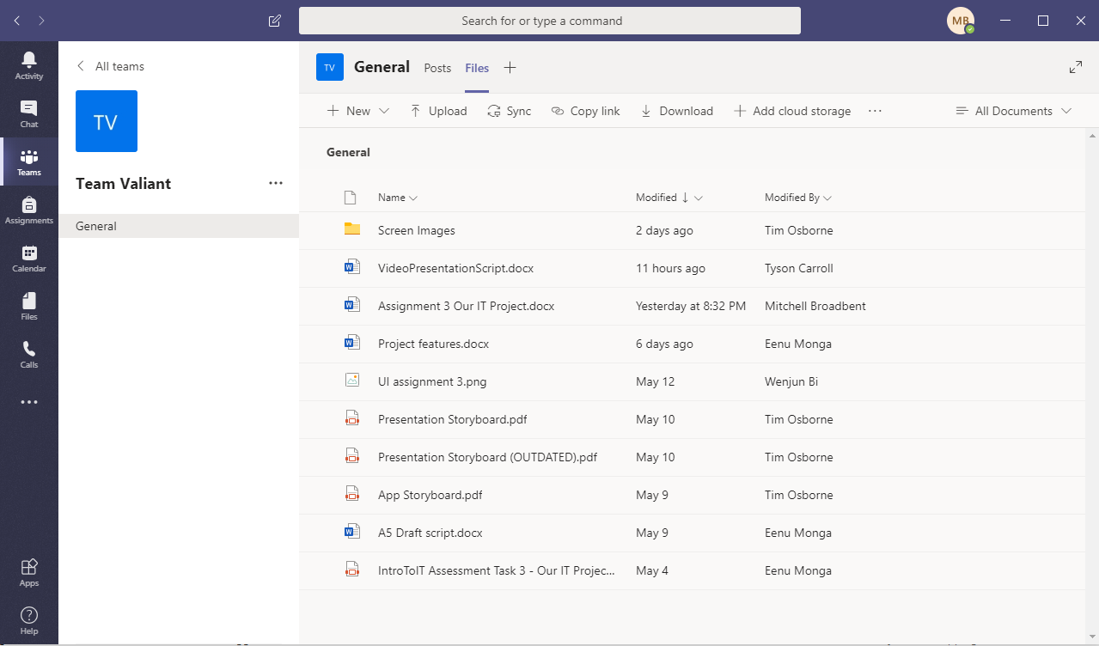Snapshot of our Team.

The same Discord server was carried over from Assignment 2, however, discussion was relegated to a separate Assignment 3 Chat channel. A separate channel was also included where a pinned checklist was kept, keeping track of the assignment’s progress.

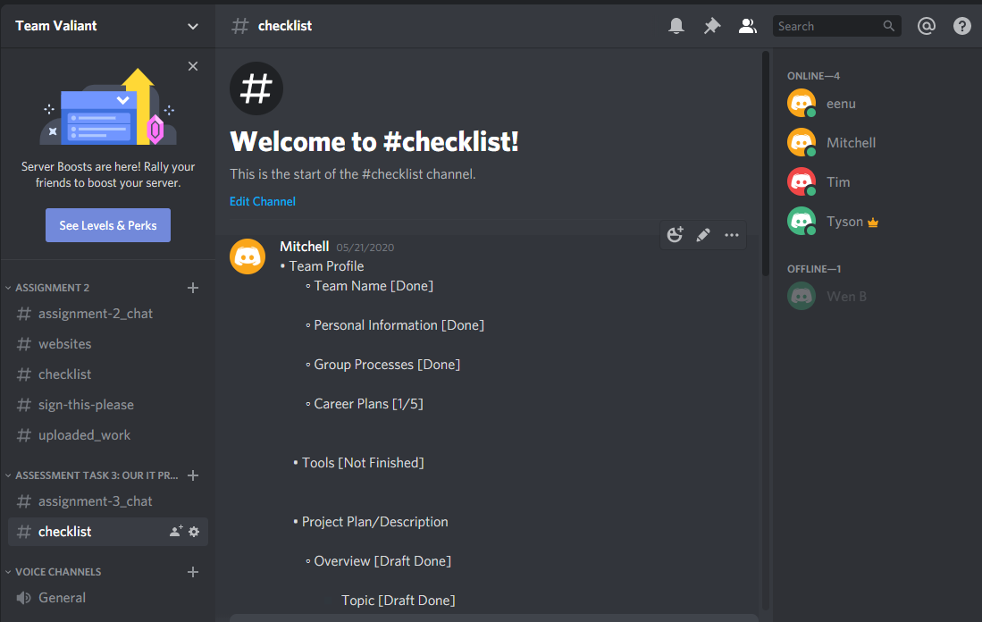Snapshot of our Discord server + checklist.

Relevant information about Team Valiant was also kept on the group’s website, which can be found here: <https://mitchell-38.github.io/TeamValiant/>

GitHub repository:

Our usernames in the GitHub repository:

Mitchell Broadbent: Mitchell-38

Tim Osborne: DaftVaderDev

Tyson Carroll: T-rmit

Eenu Monga: S3858815

Wenjun Bi: MichaelBye

Team website: <https://mitchell-38.github.io/Assignment2/>.

# Project Description

## Overview

### Topic

The purpose of our project is to use technology to create a mobile application that educates users about microbiology in a fun, engaging manner. Microbiology is the study of microorganisms (also called microbes) such as bacteria, viruses and fungi that are generally too small to see unaided (Willey & Sherwood & Woolverton 2011).

Our proposed mobile application will be an educational game that makes use of augmented reality (AR) technology to show the user how microbes are a part of their everyday lives. The application will also act as a source of truth for the benefit of public health and dispel common myths surrounding disease.

Our project is named ‘Animalcules’ after the word coined by Antony van Leeuwenhoek in the 1600s; this is what he called microbes after viewing them under a microscope as they looked like animals (Willey & Sherwood & Woolverton 2011).

The target audience for ‘Animalcules’ is anyone who has an interest in learning about microbiology. As we anticipate the majority of users will likely be primary and secondary students studying science at school, our application will aim to supplement classroom learning.

Motivation

Microbiology is an interesting area of study with real-life applications. Some microbes are of benefit to our lives – they play a role in balancing the ecosystem, are used to make food products like cheese and bread, to help create vaccines, antibiotics and other medicinal products. Some microbes are even of benefit to human health, helping digest food, synthesise vitamins and assist in the development of the immune system, while other microbes have the potential to cause disease (Willey & Sherwood & Woolverton 2011).

Currently, microbiology has never been more relevant to our lives - the world is in the midst of a pandemic caused by an outbreak of coronavirus disease (COVID-19) that has resulted in some misinformation being spread.

AR....& future employer...

### Landscape

Animalcules won’t be the first app that uses Augmented Reality and Geolocation to create an interesting gaming experience. Pokémon Go and Ingress are two games by developer Niantic that utilise similar technologies to Animalcules and involve their users wandering their local areas looking to collect game assets (Niantic 2013, 2016). However, Animalcules will have a very different focus to both games and has a much more specific targeted user-base. Furthermore, these apps do not necessarily preclude Animalcules from being successful.

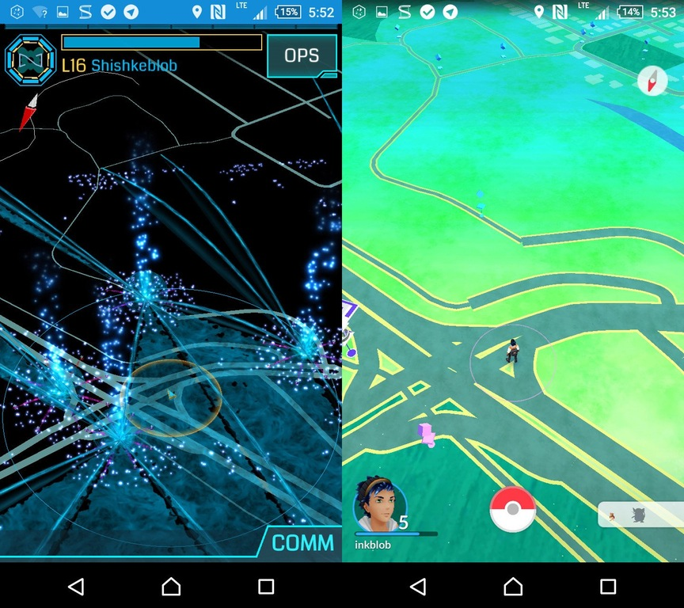

Ingress and Pokémon Go Comparison (Inkblob 2017).

Animalcules will focus on delivering an interactive, engaging yet educational experience for both high-school and primary-school students. This differs from similar AR games that are based solely on entertainment and monetisation. Animalcules also possesses real world relevance as understanding the presence of microbes (both good and bad) and their importance in society is valuable, further bolstered by the circumstance of being developed during a period of global pandemic.

The presence of similar games by Niantic does not mean that Animalcules won’t find its own place in the market. A good example is that Ingress is still a successful and popular game despite Pokémon Go being a newer and more feature heavy version of the same concept, with a much more recognisable and beloved intellectual property (Pokémon).

Niantic 2016, *Pokémon Go,* digital download, Android/iOS, Niantic.

Niantic 2013, *Ingress,* digital download, Android/iOS, Niantic.

Inkblob 2017, *Two Worlds*, Screenshot, viewed 22 May 2020, [<https://i.imgur.com/KoWusII.jpg>](https://i.imgur.com/KoWusII.jpg).

## Detailed description

Aims

The aim of this project is to develop a game available for smartphones called ‘Animalcules’ that allows user to explore their local neighbourhoods where they may find and ‘collect’ microbes by participating in mini-games utilising augmented reality and geolocation. Animalcules is to be an educational, yet engaging and fun, way to inform the target userbase (primary/high school students) about the prevalence, effect and importance of the various microbes that humans live with in modern society.

In order to develop Animalcules there are several key steps that need to be completed:

* Develop a native app for Android
* Add microbe related gameplay/information including
  + all the included microbes on launch
  + gameplay
  + videos
  + information/interactive quizzes
* Develop iOS app with the same capabilities – from here on they will be developed simultaneously
* Add geolocation and maps to iOS and Android
* Develop AR technology into the apps
* Develop the maps to accommodate public places and points of interest.
* Add further content to the game (more microbes, more information)

The most important primary step is to develop a native app for Android (this will be easier given the relative experience within the group) that can demonstrate the core features of the game. These core features include information and designs on the first hundred or so microbes available on launch, the gameplay mechanics (completing the quizzes to ‘collect’ the microbes), and adding the educational videos and information needed to ‘collect’ the microbes.

Once this initial target has been delivered, the iOS version of the game can be developed to match the same functionality and design of the Android app. From this point on, the two app versions will be developed at the same time being identical in terms of user experience. Integrating the geolocation and map SDKs will come next which can be sourced from Google directly (Google 2020).

Following this, the team with need to develop the AR technology to allow the immersive experience of interacting with microbes in their current environment. This will be achieved by sourcing the ARCore API from Google and integrating it into the two versions of the app (Google 2020).

Once the augmented reality has been successfully integrated and tested, the development can return focus back to the Maps technology to add further features such as accessing real public locations for the microbes to appear nearby and be specifically linked to. Prior to this, microbial encounters will follow a specific algorithm and will not be tied to specific locations.

Once a marketable version of the game has been completed and tested, the game can be released on Google Play and Android Appstore (Google 2020, Apple 2020). Development will continue to develop more content in the form of additional features and more microbes to find and collect.

Google 2020, *Welcome to Google Maps Platform*, Google, viewed 18 May 2020, [<https://cloud.google.com/maps-platform/>](https://cloud.google.com/maps-platform/).

Google 2020, *ARCore API Reference*, Google, viewed 18 May 2020, [<https://developers.google.com/ar/reference/>](https://developers.google.com/ar/reference/).

Google 2020, *Google Play*, Google, viewed 18 May 2020, <<https://play.google.com/store>>.

Apple 2020, *App Store*, Apple, viewed 18 May 2020, [<https://www.apple.com/ios/app-store/>](https://www.apple.com/ios/app-store/).

### Plans and Progress

**What the project will do**

* + App called animalcules
  + Use AR to interact with and collect microbes
  + Give educational experience - by playing games and watching educational content
  + Have a ‘collection tray’ showcasing acquired microbes – displays (collected/total amount)
  + GPS/Location data based experience to track microbes in the real world
  + Allow user to have an avatar
  + Have a section dedicated to public health topics to dispel myths and provide facts

How *Animalcules* began:

Our project started as a basic concept that can be summed up in one sentence:

*Microbiology meets augmented reality.*

Microbiology is an interest of Eenu’s and is a practical field of study with real-life application. It is not abstract or objective, and while we cannot necessarily see the microbes themselves, they do impact our lives in one way or another.

Augmented reality is the addition of information to the reality we experience in real-time (Emspak 2018; Interaction Design Foundation 2019; Marr 2018).

Pokémon GO was an excellent example of how this technology was used to create a fun and interactive experience and is an inspiration point for *Animalcules*.(quick sentence describing what Pokémon GO is).

When combined, *Animalcules* will use augmented reality to show the user where or when microbiology is present. The idea is the user will be alerted to when there are microbes nearby; they are located in places that involve microbiology. When they are close enough to the microbes/situation, the user is then given an educational experience that is engaging and informative. The educational experience will comprise of either a mini game related to the particular microbe/situation, an educational video, fun facts or an interactive quiz. Upon successfully completing the educational experience, the user can re-play as many times at their own leisure.

A secondary purpose of the application is provide facts and dispel myths, public health is important.

Our progress with *Animalcules*:

The basic concept of *Animalcules* needed development before it could progress on the application itself went any further. When the project was presented to the rest of Team Valiant, it was clear there were different ideas for what the project may look like, and that some aspects needed to be more specified.

**While we had all these ideas, we needed to understand what our project would actually look like, dive into specifics and think about how this would be achieved.**

**This ties into our Limit & Scope – in the time we have, it is not feasible to start writing the software. Instead, we needed to visually present our project.**

Below are the decisions that our team has made in relation to *Animalcules*:

Decision made regarding project name and format:

The project was nameless, we decided on ‘Animalcules’…

**Figure 1/Artefact 1: ‘Animalcules’.** A title for our project was decided.

Decisions made - target audience & user engagement:

The original target audience for *Animalcules* was vague; it was originally aimed for any person with an interest to learn about microbiology. While we want *Animalcules* to be an inclusive application, keeping the target audience vague would mean it could be hard to market, and being too broad also makes it difficult to create the right level of language, explanation and scientific content. Therefore, it was decided that the target audience would be primary and secondary students, and that this application could be used by schoolteachers and parents to supplement the existing school curriculum.

The original project idea also did not have a clear idea of progression – would *Animalcules* be a game that had defined levels? Or would the user just be given a number of the amount of activities there were to complete? The team decided that using levels comes with the expectation of increased difficulty and that is was not suitable for this application. Instead, as the original project idea mentioned users should be able to re-play the activities at their own leisure, it was decided there should be one place to access these, and that seeing how many activities were completed vs those not yet completed would be more motivating and engaging for a user.

Below is a draft screen we have created below.

**Figure 2/Artefact 2: ‘Your Collection’.** This screen is where users can see the activities they have completed, and activities they have not yet completed.

Another decision that had been made was to add an element of personalisation by allowing users to create an avatar while using the *Animalcules* to make it more engaging.

Decisions made – Where will users see the microbes? How is this shown to the user? Defining the user experience:

Defining when and where users will see microbes/educational experience needed to be specified as it would determine how the application needed to be built. The original project proposed that all educational experiences in the application would be triggered by two reasons:

1. Location

2. Current events

Location is defined as places that involve a concept of microbiology in some form and some examples have been provided in **Table xx.** The majority of places are physical places, while some are objects/markers.

Current events include events of microbiological significance, such as flu season.

After a group discussion, it was also decided that some microbes would need to be triggered not by location or product but randomly.

**Table xx/Artefact 3:**

|  |  |  |
| --- | --- | --- |
| MICROBES/MICROBIOLOGICAL CONCEPT | TRIGGER | INTERACTIVE ACTIVITY |
|  |  |  |
|  |  |  |
|  |  |  |
|  |  |  |
|  |  |  |

If the microbe is near a hospital, etc they could watch a video about hospital-acquired infections, etc. If the microbe is triggered by an object, we will provide clues (make a screen draft). If a microbe exists on different surfaces, the user could scan using their phone to find it (make a screen draft).

The original user experience was that the user would be going about their usual life and when passing by a defined location, receive a notification about the presence of microbes. Then, when looking at their surroundings through the camera while in the application, they would see an AR element on the screen that would then link them to an educational activity or activities which they would then need to complete **(Figure 3**).

**Figure 3/Artefact 4: The AR layer**. An example of the augmented reality in the application.

In a way, this was actually a *passive* experience for the user; the application would just be functioning in the background, and the user most likely wouldn’t open it unless they received a notification. The user wouldn’t actually know how far away the next microbe/activity would be, and in the absence of any clues or ideas (which while mentioned in the original plan, were not intended to be timed or implemented on a regular basis) we assumed that motivation/engagement would be quickly lost.

If the main target audience is to be engaged, the way they interacted with the application needed to be different. This led to a key change to the project plan: we decided we show users where nearby microbes/activities were to encourage them to seek out a learning experience. It would also suit our target audience for planning school excursions or for parents/caregivers wanting children to learn outside of school. In **Figure 4** below is an example of how this would look like.

**Figure 4/Artefact 5: *Animalcules* maps.**

The user experience is suddenly more engaging and motivates the user.

**How will you do it**

* + Learn and implement java
  + Implement Augmented Reality
  + Get designer for app and virtual microbes

**Public health/dispel myths section here**

**How Team Valiant will do this**

· Have a target list of microbes and their associated learning activity and determine how where they will be located or how they will be triggered. Have a draft of how the concept will look like. Hire a professional designer for the actual designing/UI.

· Build the program with Swift and Xcode for iOS/iPhones <https://learnappmaking.com/how-to-make-an-app/#design> and Java for Android phones using Java Development Kit (JDK) software and a useful integrated development environment (IDE) will be required.

· Augmented Reality:

Augmented reality can be used in different ways mobile applications: location-based and marker-based.

Location-based: the AR is triggered by location. An example is Pokemon GO, a location-based AR application that works using GPS, compass, etc

Marker-based: the AR is triggered by an object (known as a marker).

Animalcules would actually be a combination of a location-based application and a marker-based application. Primarily be location-based, with some marker-based content.

See what existing programs/software could be used already

<https://www.infoq.com/articles/augmented-reality-best-skds/>

<https://www.blippar.com/blog/2018/08/14/marker-based-markerless-or-location-based-ar-different-types-of-ar>

· **Think about how the back-end (data storage) will work, pick a cloud-based option to save storage on phone**

**Creation of the App Mock-ups**

The creation of the mock-ups for the purposes of this document was done using an open source program known as Paint.net (<https://www.getpaint.net/>) that allows for the creation and manipulation of images. Using PokemonGo as a reference I used a basic phone outline as a basis for all whole thing, I then used a website to create a simple but interesting title card and team font for the opening page of the app (<https://cooltext.com/>). From there I used a place called the Australian National University as a location to create how the app might look once its running specifically the area around their department of nuclear physics as a backdrop for the UI elements. I then created simple shapes to serve as buttons and using a simple image from the internet created a few virus images to serve as placeholders for what the actual microbes would look like as well as how the app would look if you brought up the sub-menu to find local instances of the microbes. I created the collections page simply by using 3 different images of virus’s and randomly arranging them to appear as if they had been collected previously and were there to display how far a player had progressed through the list of microbes. The screen containing the minigame for capturing the microbes was made using the pre-existing virus placeholder and another simple shape to form a button and using the Royal Melbourne Hospital as a backdrop for it to serve as a hint to where users might find a large variety of microbes. To create the backdrop for the news segments I found empty news sets at (<https://www.newscaststudio.com/setstudio/>) and layered several mock-up images of the app to the side to emulate how an actual studio might display them.

### Roles

Developing an ambitious and complex project like Animalcules would not be possible without being able to break down what needs to be done and making sure each member knows what they are responsible for. Because of this, Team Valiant has designed several roles which will ensure productivity and clarity in the development process:

* + Project Manager
  + UI/UX Designer
  + Developer
  + Quality Assurance Specialist
  + Marketing Specialist

Any project of this size requires a project manager. It is the project manager’s responsibility to distribute tasks and coordinate communication among the project members. The project manager maintains the ‘big picture’ direction of the project and is responsible for time management, conflict resolution and keeping the project on track.

As Animalcules will be a mobile phone app, it needs to have engaging and pleasing user interfaces (UI) and experiences (UX). For this reason, a UI/UX designer is needed to design the visual elements of the app.

The developers will be the ones responsible for putting the project together – in this case, coding the application. The developers will be responsible for receiving design ideas from the designer, directives from the project manager and turning that into a deliverable product. This would entail programming the Android and iOS apps and integrating the relevant technologies into it. The need for the developers goes without saying as there would be no app without the developer to make it.

The quality assurance specialist is responsible for conducting the testing and reporting bugs, detecting errors and providing useful feedback for the developers. The quality assurance specialist will organise and carry out the user testing and feedback stages of the app development. Once some testable aspects of the app have been delivered, one of the developers will need to take over the role, as the role is not necessary until that point.

The marketing specialist is responsible for conducting market research and later launch marketing campaigns to generate interest in the app. It is up to the marketing specialist to determine how certain prospective features will impact the success of the app, maximising the potential of the app when released.

### Scope and Limits

Given the virtually limitless list of known bacteria, viruses and fungi that could be added to the game, it would be far too ambitious to try to release the game all of them in it. Instead, the game will release with a limited number of microbes, approximately a hundred to start with. These microbes will be the most iconic and prevalent to modern society. Further microbes can be delivered later as content updates. It important however that these first microbes are completed to give the users a sense of what the game is all about.

The primary focus of the app will be developing the core educational gameplay, microbe collections and basic geolocation tracking. Augmented reality will be developed with a secondary emphasis and is not necessary for the app to function. It will be developed once the core features are nearing completion.

Geolocation is an integral part of the Animalcules experience and cannot be missing from the game upon release. However, to be functional the app only needs to be able to track the location of the user with updated maps. Ideally, the app will be able to recognise popular public locations, identifying the type of location and which types of microbes may be found there, however that will not be the priority of the initial product.

### Tools and Technologies

To develop a popular mobile app, the project will need to be developed in a programming language. To cover a large share of the mobile market, the app will need to be developed for Android phones and iPhones.

The official language for coding Android apps is Java, so the Java Development Kit (JDK) software and a useful integrated development environment (IDE) will be required (Oracle 2020). Android Studio is a popular IDE designed specifically for Android development and would be an ideal tool for the project (Google 2020).

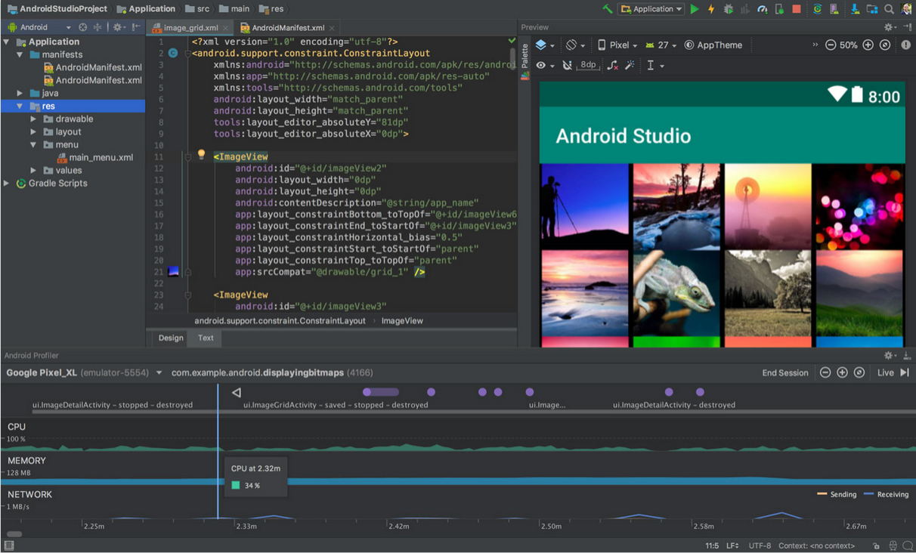Android Studio (Google 2020).

Mitchell has prior experience in programming with Python and is currently taking an introductory programming course based in Java.

Apple phones have been primarily developed using Objective-C. However, recent apps have been developed in a relatively new language called Swift, which is compatible with Objective-C (Apple 2020). Swift is widely considered to be faster and easier compared to its predecessor, and results in fewer vulnerabilities in the code. This is ideal because user-data security will be a high priority with our game, as the target market will be for school-age children. Xcode is an open-source, popular and versatile IDE used in developing Swift applications (Apple 2020).

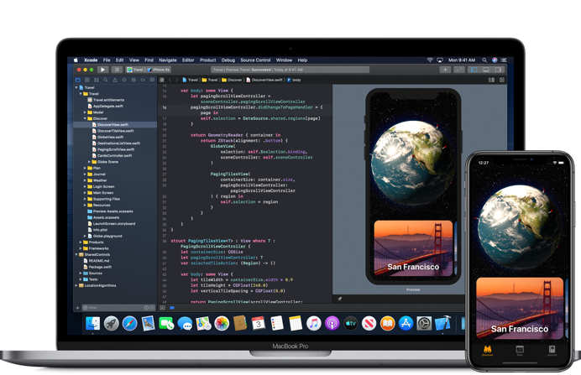

XCode (Apple 2020).

Animalcules will be a location-based app, which means that geolocation technology will be necessary to implement into it. For this, two components are needed: location services and maps. Google offers their Maps software development kit (SDK) for both Android and iOS, and a geolocation application programming interface (API) (Google 2020). Both of these technologies will need to be licensed from Google if they are to be implemented into Animalcules.

The game will be released on the Apple App Store and Google Play which will require licenses from the respective platforms (Google 2020, Apple 2020). The app will also utilise Google’s ARCore API to develop the augmented reality technology, which will require further licensing to use (Google 2020).

Oracle 2020, *Java SE Downloads*, Oracle, viewed 18 May 2020, <https://www.oracle.com/java/technologies/javase-downloads.html>.

Google 2020, *Android Studio*, Google, viewed 18 May 2020, [<https://developer.android.com/studio/>.](https://developer.android.com/studio/)

Google 2020, *Android Studio,* screenshot, viewed 18 May 2020, [<https://developer.android.com/studio/images/studio-homepage-hero.jpg>.](https://developer.android.com/studio/images/studio-homepage-hero.jpg)

Apple 2020, *Swift – The Powerful Programming Language That Is Also Easy To Learn*, Apple, viewed 18 May 2020, [<https://developer.apple.com/swift/>.](https://developer.apple.com/swift/)

Apple 2020, *XCode 11*, Apple, viewed 18 May 2020, [<https://developer.apple.com/xcode/>.](https://developer.apple.com/xcode/)

Apple 2020, *XCode 11*, image, viewed 18 May 2020, [<https://developer.apple.com/xcode/images/hero-lockup-medium.png>.](https://developer.apple.com/xcode/images/hero-lockup-medium.png)

Google 2020, *Google Maps Platform Documentation*, Google, viewed 18 May 2020, [<https://developers.google.com/maps/documentation/>.](https://developers.google.com/maps/documentation/)

### Testing

Animalcules will go through several stages of testing headed by our quality assurance specialist to ensure robust app development. This is important as there are several key technologies underpinning the functionality of the game.

The first line of testing will just include testing the basic interface that’s been developed. If there are no obvious bugs in the app at this point, it will time to move on with development.

The next stage of testing will be more intensive and focus on the development of the geolocation and map technology. This will allow the opportunity for users to come in early in the development stage to provide feedback about the core mechanics of the game and general user experience when going outside and encountering microbes. The target audience for Animalcules will largely fall in the primary/high school age range; however, the test users will be ideally selected from the 18-24 age range to avoid any legal issues. Around 20 people should be sufficient as the feedback should be brief statements about their interactions with the game. These test users will be gathered from email lists, beta-testing websites and by reaching out on social media sites such as Facebook and Reddit. Test users will be offered $10 for their time since the testing will be a small app download and few minutes of their time. The test version of the app will be quite limited with a set number of encounters, just long enough to gather quality feedback without users losing interest. These users will be asked if they’re willing to sign up for further testing on a more complete version of the app with added features.

Once the augmented reality technology has been added to the app, the next stage of testing will be initiated. Users who were signed up for further testing will be contact and more users will be found as necessary. This version of the app will be closer to a final product that will be released; and as such, will require a greater and more intensive testing period. Testing requirements will include wandering around their local areas, encountering and collecting microbes and providing feedback about the experience. The number of test users will be expanded up to 100 players, and financial compensation will increase based on the amount of time players have spent testing the app, to a maximum of a few hours of their time.

### Timeframe

### Risks

A project like the development of Animalcules is an ambitious endeavour with multiple independent technologies and software platforms working in conjunction with one another. As such, there is an extensive number of risks that must be considered when undertaking such a project.

On the surface level there are such risks as the app not being popular enough among the target demographic (or conversely, too popular), but there are also more specific risks that would not usually be thought of if we didn’t spend time evaluating them.

Each one of these risks must be explored for their likelihood and which actions may be taken to mitigate their effects. As previously mentioned, popularity is a large concern for any app developed and released to the public. On one hand, the app simply may not be popular to potential users and it will either fail to gain traction, or fail to gain enough attention soon enough to avoid being buried by rival apps due to the fast-paced nature of app development. To avoid the risk of developing an app only to have it fail, it would be prudent to conduct market research to the popularity of similar apps and the current ‘need’ for an app that fills our project’s purpose. This does not eliminate the risk entirely but provides crucial insight into its potential. On the other end of the spectrum, it’s possible that Animalcules could become too popular for Team Valiant to handle. If the app’s popularity outpaces the growth of the development team, the support team may struggle to keep up and conversely cause the app’s popularity to sharply decline. Furthermore, increased popularity generates more server activity and the likelihood of technical difficulties. Pokémon Go, a similar app experienced this issue when it launched; and the problem resurfaced during their first official event which resulted in the developers (Niantic) having to reimburse event goers as it was not even possible to log into the app (Holly 2017).

Security and privacy are both major sources of risk when developing an app that must be discussed in tandem due to their symbiotic nature. For instance, encryption is crucial to security, and if the app wasn’t encrypted, then that data could be compromised and thus the privacy of users is compromised. User privacy is a top priority with Team Valiant, as and such it is especially important to safeguard data and keep user data private – even from the development team. Since one of the game’s core mechanics involves tracking a user’s global position relative to public landmarks, all traffic needs to be encrypted. Encryption isn’t the only consideration that needs to be made, but how the data is stored, and company cybersecurity practices are risk factors that need to be addressed before storing the data of potentially thousands of underage children.

Government legislation is a large risk to the success – or even legality – of Animalcules. There are numerous laws governing the handling and storage of user data – particularly with minors – and it is necessary to understand how these laws will affect Animalcules. With media attention surrounding digital privacy, these laws may be subject to drastic changes in the next few years. Not only does the likelihood of changing laws need to be evaluated but being unaware of the regional laws of the users is a risk as well. This increases the risk that legislation may prevent Animalcules from existing in its ideal state, despite the intentions and value of privacy behind the development. In 2020, the popular social media app TikTok was still not using encryption for their data transfers and came under scrutiny (Olenick 2020). The predecessor to TikTok, Musical.ly also found themselves in legal trouble due to illegally gathering the personal data of children (Olenick 2020). Incidents like these demonstrably highlight the security and privacy risks when it comes to developing an app, and this is something that will not go under the radar with Animalcules.

Just like governments, platform selection is an external risk factor that cannot be directly controlled. Users find popular apps through their respective phone’s app-store (for Animalcules this is Apple Appstore and Google Play), and as such Animalcules will need to comply with the terms and conditions of these platforms (Google 2020, Apple 2020). Apps can face rejection from platforms, and it would be unfortunate to develop an app only to be without a platform to upload it to. On the other hand, there is the risk of choosing the least ideal platform to upload the app to. Android and iOS are considered the most popular operating systems for smartphones, but it’s entirely possible that users most likely to download and enjoy Animalcules prefer Windows (or any other) phones and as such Team Valiant would be missing out on a valuable market share for their app. Ideally, Animalcules would be available natively for all platforms, however development takes time, money and effort - which brings up the other risk of overdeveloping the app to diminishing returns on investment.

Monetisation is an important factor the success of any published application, not just for the success of the company, but also in terms of having the funds to continue support and development for the app. Choosing the wrong monetisation option runs the risk of failing to capitalise on an app’s popularity, costing the company dearly in missed revenue. Conversely, choosing the wrong monetisation option for the app may also negatively impact the popularity of the app. Users tend not to want to pay money for apps, choosing the free option if they can. If the app has too high of an upfront cost, overly monetised in-game purchases or pervasive and annoying advertising; users will be turned off and thus the popularity and therefore success of the app could be greatly diminished.

When developing an app, or any project for that matter, some of the greatest risks are being unable to deliver the project on time or under budget. These are absolutely some of the biggest risks that need to be considered moving forward with Animalcules. Team Valiant needs to be realistic about what can be achieved and needs to avoid increasing the risk of being unable to develop the project. To avoid this risk, finding the right compromise between time, budget and functionality is key. Developing the app within the constraints of contemporary smartphone performance means there is a risk that the app could end up too demanding for phones to run, or run well enough for users to keep using it. This brings up the compromise problem again of finding the right balance between performance and features/functionality. However, if the app runs well on phones, but doesn’t have enough engaging features, users won’t stick around.

Finally, there are a series of internal risks surrounding group management and project development. Employee turnover (or group members leaving), is a major concern that can greatly impact how or even whether the project will turn out. Animalcules is a long-term project requiring a development plan that stretched into months and years, and as such it is probable that members in the development team will either leave or become unable to continue on the project all the way through. Being able to prepare for and mitigate the impact of this risk is vital to being able to develop a successful project. For example, if there is only one developer who knows how to write the code for the application, the loss of that member would cause the project to fold. There are also various internal procedural risks that could become issues for the development team going forward. Conflicting priorities, lack of clarity and poor communication will quickly result in a bad or unfinished project. It is important that all members are kept up to date on what the primary focus is for the app’s development and to make sure that proper discussion and communication is had before any major decisions are made by individual members.

Holly, R 2017, *'*Pokemon Go Fest refunds all tickets as players can’t get game to work’, *Chicago Tribune*, 22 July 2017, viewed 18 May 2020, <<https://www.chicagotribune.com/business/blue-sky/ct-bsi-pokemon-go-fest-day-20170722-story.html>>

Olenick, D 2020, ‘TikTok app inherently unsafe and a privacy risk’, *SC Media,* 15 April 2020, viewed 18 May 2020, <<https://www.scmagazine.com/home/security-news/privacy-compliance/tiktok-app-inherently-unsafe-and-a-privacy-risk/>>

### Group processes and communications

## Skills & Jobs

* Manager of a team of 4 to deliver the project outcomes
* Write four position descriptions for people that you would employ to take your project to the next phase
* What skills are appropriate?
  + Technical expertise
  + Team work experience
  + Leadership and management techniques
  + Innovative thinking

Positions would be similar to the predefined roles above including

UI/UX Designer

Developer

Marketing Specialist

Quality Assurance Specialist

Feedback

## Group Reflection

**References**

Emspak, J 2018, What is Augmented Reality, viewed 22 March 2020, <https://www.livescience.com/34843-augmented-reality.html>

Interaction Design Foundation 2019, Augmented Reality - The Past, The Present and The Future, viewed 23 March 2020, <https://www.interaction-design.org/literature/article/augmented-reality-the-past-the-present-and-the-future>

Marr, B 2018, 9 Powerful Real-World Applications of Augmented Reality (AR) Today, viewed 22 March 2020, <https://www.forbes.com/sites/bernardmarr/2018/07/30/9-powerful-real-world-applications-of-augmented-reality-ar-today/#a0e03a52fe95>.

Willey, JM, Sherwood, LM, & Woolverton CJ 2011, *Prescott’s Microbiology*, 8 edn, McGraw-Hill, New York, USA.